Project Design Phase-II
Technology Stack (Architecture & Stack)

Date | 1 June 2026
Team ID
Project Name | ShopEZ: E-Commerce Application
Maximum Marks | 4 Marks

Technical Architecture: 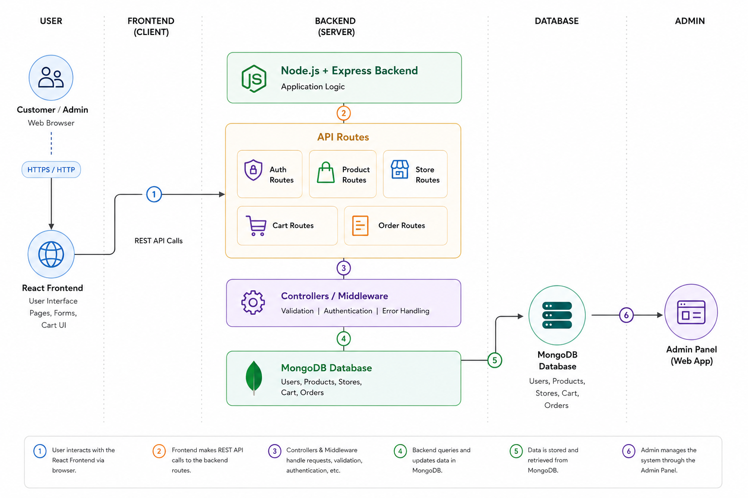

Table-1 : Components & Technologies:
S.No | Component | Description | Technology
1 | User Interface | Web interface used by customers and admins to interact with the application. | React.js, HTML, CSS, JavaScript
2 | Application Logic-1 | Handles user registration, login, authentication, and user session management. | Node.js, Express.js
3 | Application Logic-2 | Handles product listing, product details, product creation, update, and deletion. | Node.js, Express.js
4 | Application Logic-3 | Handles store management, cart management, and order processing. | Node.js, Express.js
5 | Database | Stores user, product, store, cart, and order data. | MongoDB / NoSQL
6 | Cloud Database | Cloud database service for storing application data if deployed online. | MongoDB Atlas
7 | File Storage | Stores product images and static frontend assets. | Local filesystem / Cloud storage, future scope
8 | External API-1 | Payment gateway for online payment processing, if implemented in future. | Razorpay / Stripe / PayPal
9 | External API-2 | Email or notification service for order confirmation, if implemented in future. | Email API / SMTP, future scope
10 | Machine Learning Model | No machine learning model is used in the current version. Can be added later for product recommendation. | Not applicable / Future scope
11 | Infrastructure | Application can run locally during development and can be deployed on cloud for production. | Localhost, Render/Railway for backend, Vercel/Netlify for frontend

Table-2: Application Characteristics:
S.No | Characteristics | Description | Technology
1 | Open-Source Frameworks | The application uses open-source frameworks and libraries for frontend and backend development. | React.js, Node.js, Express.js, MongoDB, Mongoose
2 | Security Implementations | User authentication and protected routes are used to secure user/admin access. Passwords should be stored securely using hashing. | JWT, bcrypt, CORS, environment variables, form validation
3 | Scalable Architecture | The system follows a 3-tier architecture: frontend, backend, and database. Each layer can be scaled separately. | React frontend, Express REST API, MongoDB
4 | Availability | The application can be deployed on cloud platforms so users can access it online. Backend and database services can be hosted separately for better availability. | Vercel/Netlify, Render/Railway, MongoDB Atlas
5 | Performance | REST APIs, reusable frontend components, database indexing, and optimized queries improve performance. Static files can be served through CDN in production. | React optimization, Express APIs, MongoDB indexes, CDN

